
BATTERY BOX AND DOOR
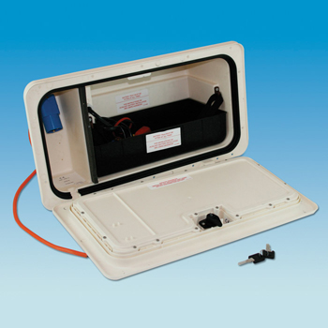

TECHNICAL SPECIFICATION.
BOX AND DOOR MATERIAL: ASA
MAINS CABLE: 3 CORE 2.5mm²
BATTERY CABLE: 2 CORE 4.0mm²
COMPATIBLE BATTERY DIMENSIONS
