

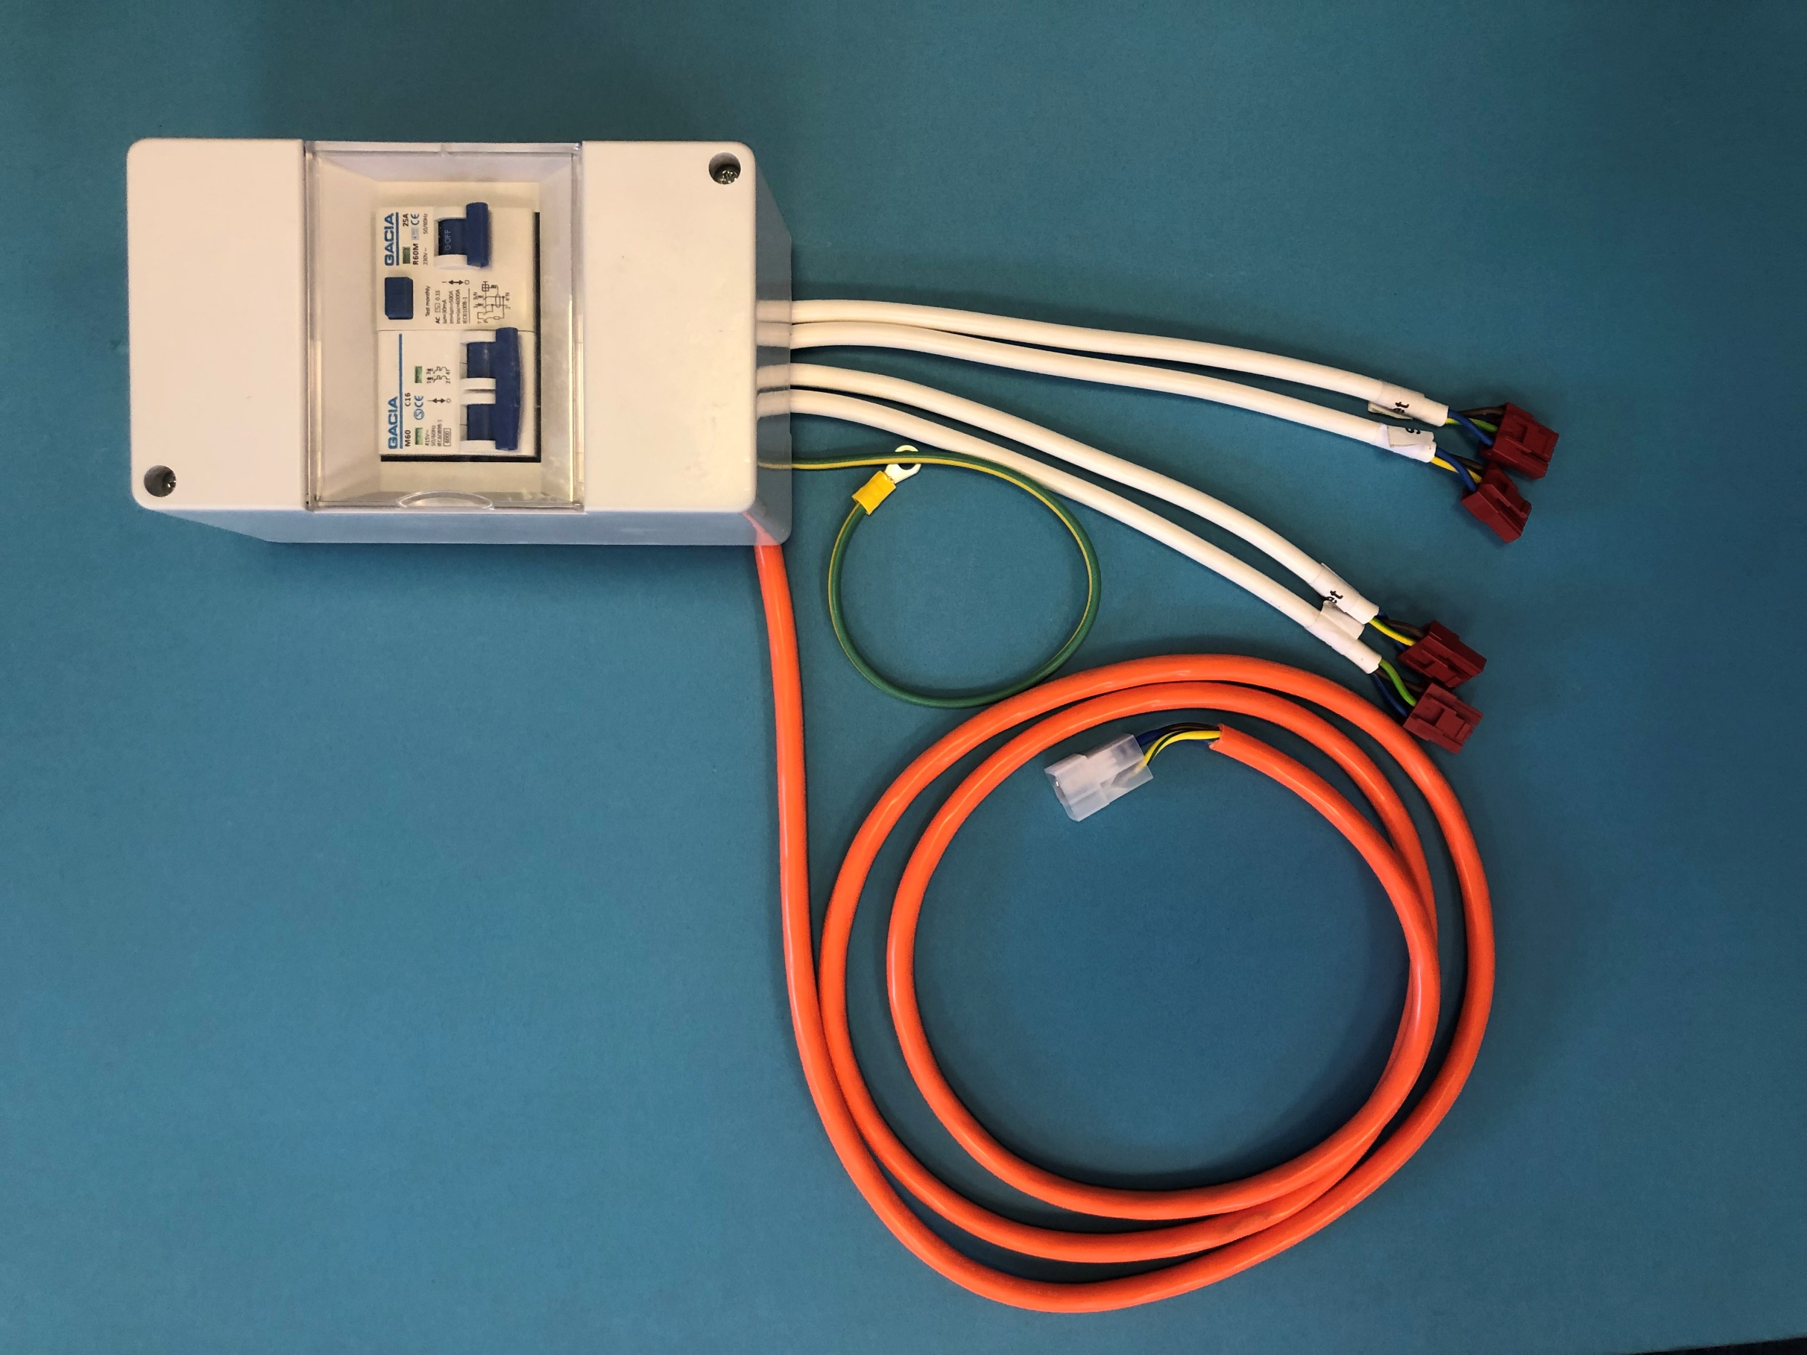
INSTALLATION SHOULD ONLY BE CARRIED OUT BY A COMPETENT PERSON
PREWIRED MAINS CONSUMER UNIT
INSTALLATION GUIDE
Installation Guide for “Power Part” Pre-Wired Mains Consumer Unit
- INSTALLATION SHOULD ONLY BE CARRIED OUT BY A COMPETENT PERSON

Congratulations with your purchase of the “power Part” Pre-Wired consumer unit kit for caravans, motor homes and campervans.
Before installation please check the contents list.

Contents:
- Pre-Wired Consumer unit consisting of:
- 25 Amp, 30mA Residual Current Devise
- 16-amp MCB (Double pole type C)
- 5 Module enclosure
- 4 x 230V output connections (Red VLP-03)
- Earthing Wire
- 1 x Mains inlet connection (t-shaped three way)

- 5 x Easy connect Enclosures (4 x light grey, 1 x dark grey)

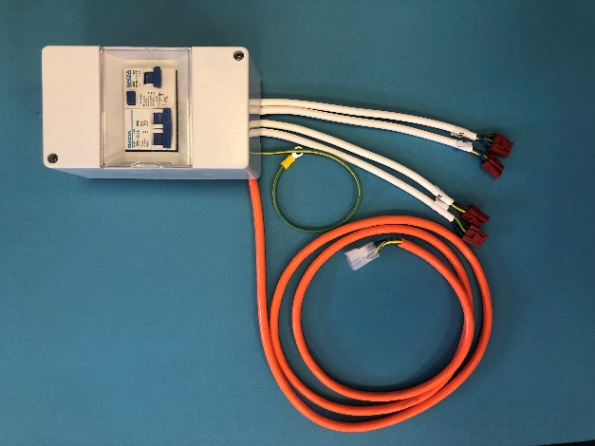
5 Modular Enclosure
RCD
MCB

Earth Wire
Mains Inlet Connection

4 x 230V Outputs

Note: All pictures shown are for illustration purpose only, actual products may vary due to product enhancement
FITTING INSTRUCTIONS
- INSTALLATION SHOULD ONLY BE CARRIED OUT BY A COMPETENT PERSON

- Fitting the Consumer Unit
- Fit the consumer unit by removing the front cover which are fixed by screws A (fig 1)
- Fix the unit to the required surface with 2 8x1 screws at fixing point B (fig 2)
- Re-fit the front cover.

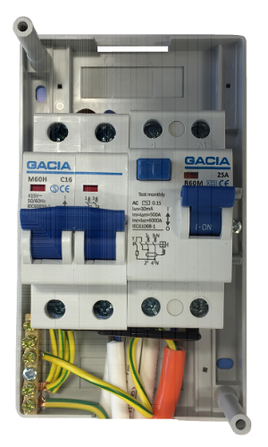
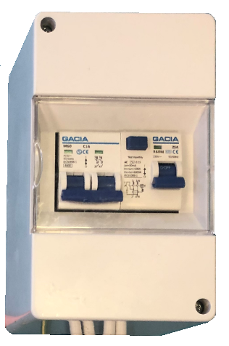
B
A

B
A

Fig 2
Fig 1

- Fixing the earth bonding cable.
- Connect the earth cable to the fixing point of the chassis, refer to the vehicle information if a hole is required.
- The earth cable is fitted with a 6mm ring terminal.

- Connecting the inlet.
- The unit comes with a pre-wired connector on the orange cable to connect to a pre-wired inlet using the supplied easy connect enclosure (fig 3+4), pre-wired inlets can be purchased from the “Power Part “Range.
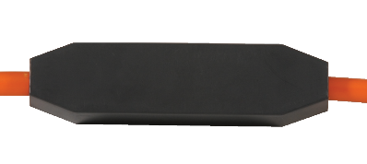
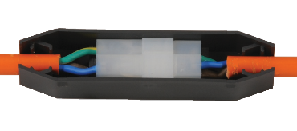
Fig 4
Fig 3

- Connecting Sockets and Extensions.
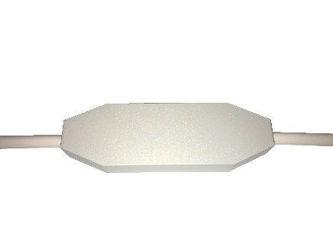
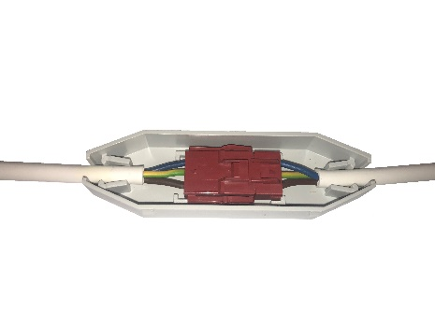
- The unit comes pre-wired with 4 x output feeds (white cable) with connectors which can be attached to various pre-wired sockets and extensions using the supplied light grey easy connect enclosures (fig 5+6), sockets and extensions can be purchased from the “Power Part “Range.

Fig 6
Fig 5

- Fixing the cable to the vehicle.
- Use clips (not supplied) to fix the cable to the vehicle at 400mm intervals for vertical runs and 250mm for horizontal runs.
Note: All pictures shown are for illustration purpose only, actual products may vary due to product enhancement

- Test and Inspection.
- INSTALLATION SHOULD ONLY BE CARRIED OUT BY A COMPETENT PERSON

- After installation is completed, we recommend an initial inspection is done in accordance with BS7671 by a competent person.
- We recommend periodic testing of the RCD by pushing the test button the RCD.
- INSTALLATION SHOULD ONLY BE CARRIED OUT BY A COMPETENT PERSON

Other Products in the 230V Pre-Wired Power Part Range include (entire range is compatible with the pre-wired consumer unit).

- Pre-Wired Inlets.
- Pre-Wired Sockets.
- 230v Output extensions (1M,2M,3M_
- Splitters (allowing to loop from socket to socket)
- Mains Leads (Various Lengths)
When Connecting to the pre-wire range ensure all 230V connections are covered and secured and only accessible via a use of a tool, All electrical systems must be installed and tested by a competent person in accordance with BS7671.

Please ask your dealer about the Power Part range, alternatively please visit the website to see a full list of products WWW.PLSGROUP.CO.UK




Note: All pictures shown are for illustration purpose only, actual products may vary due to product enhancement

